**HIRDA-HT**

**High temperature resistant infrared thermal imaging temperature detection and analysis system specification**

2024年2月

**HIRDA-HT High temperature resistant infrared thermal imaging temperature detection and analysis system specification**

1. **System Introduction**

HIRDA-HT High temperature infrared thermal imaging temperature detection and analysis system is a special infrared thermal imaging product for use in high temperature environment. The system is mainly composed of infrared thermal imaging module, infrared lens, high temperature resistant metal shield, control box, image algorithm server and client software.

The system adopts full radiation temperature measurement technology, which can obtain multiple temperature values at the same time. Measuring temperature range up to 2500℃; Self-developed temperature measurement algorithm, high temperature measurement accuracy; Water-air cooled stainless steel shield design, IP66 protection grade, can work normally under high temperature environment of up to 500℃; The system software can realize target display in infrared heat map, thermal data collection, storage and analysis, high and low temperature alarm and positioning, temperature tracking and other functions.

This product has been widely used in metallurgy, electric power, cement, glass and many other industries of high temperature furnace temperature monitoring.

The product field application diagram is shown in Figure 1.

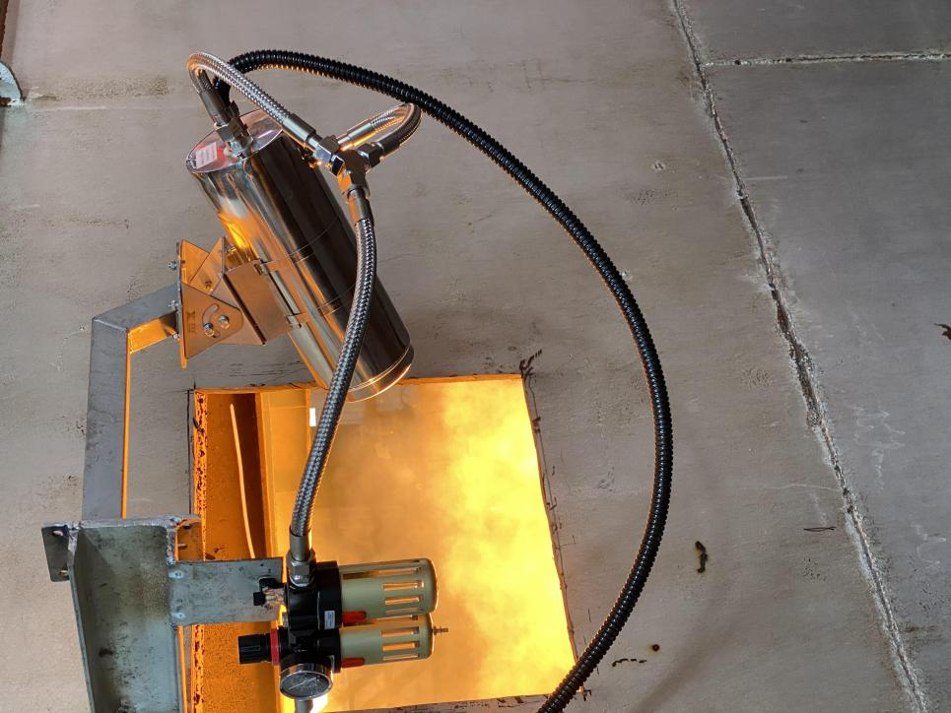

Figure 1 Product application of HIRDA-HT system

1. **System Features**

* Water-cooled high temperature resistant design, withstand 500℃ ambient temperature in the maximum;
* High protection level, protection level up to IP66;
* automatic window purging, no need to manually clean the window regularly;
* does not depend on system platform, can directly log in to the web page to access the image and configure, can directly output alarm signal to PLC or alarm;
* Support onvif protocol;
* Electric/auto focus, adjust focus any time through the software;
* Temperature range can be customized, the maximum support -40℃ to 2500℃;
* The temperature measurement accuracy is better than ±2℃ or ±2%;
* supports modbus and connection to the DCS for temperature data transmission.
  1. **System utility Requirements**

**2.3.1 Power**

Field probe power supply 220VAC 50/60HZ power 50W/ set

Power supply for control room: 220VAC 50/60HZ power 300W

**2.3.2 Cooling gas**

Gas type: dry compressed air or nitrogen, instrument gas

Compressed air temperature: ≤35℃

Compressed air pressure: ≥ 0.4Mpa

Compressed air flow: 0.1-0.2m3/Min

**2.3.3 Cooling water**

Cooling water temperature: ≤35℃

Cooling water pressure: 0.1-0.4Mpa

Cooling water flow: 0.2-0.6m3/h

1. **Application Scenarios**

Furnaces, materials and solution temperature collection in high temperature industries such as iron and steel smelting, non-ferrous metals, cement and glass And analysis.

1. **Main technical indicators**

|  |  |  |
| --- | --- | --- |
| Model | PFCDG300-NSxxExx | |
| Product picture | PFCDG300-2 | |
| Infrared resolution | 384×288 | 640×480 |
| Infrared lens selection | 4、8、13、25 | 8、19、25、35 |
| Infrared field Angle | 80°、45°、25°、15° | |
| Wavelength coverage | 8～14μm | |
| Heatsensitivity  (NETD) | ≤50mk@30℃ | |
| Frame frequency | 25Hz | |
| Focus | Electric/automatic | |
| vision algorithm | Gamma correction and enhancement algorithm | |
| temperature measurement accuracy | ±2℃ or ±2% | |
| Temperature range | -20℃ ~ 1600℃ (need to be segmented), can be extended to 2500℃ | |
| Network video compression format | H.264/H.265 | |
| Data type | H264、H265、16Bit raw temperature data | |
| Web standard | Gigabit network/Adaptive 100M/1000M | |
| Protocol support | IPv4/IPv6、TCP、UDP、NTP、HTTP、RTSP、RTP、ICMP、WebSocket、ONVIF | |
| Temperature output | Support analog 4--20ma, RS485, Modbus TCP/RTU | |
| External triggering | Supports RS485 level and TTL level | |
| Level of protection | IP66 | |
| Size | Φ127mm×300mm | |
| Type of cooling | Water-air cooling/air cooling | |
| Installation mode | Equipped with PTZ support | |
| Weight | ≤7Kg | |
| Operating temperature | -20℃～500℃ | |

1. **Machine structure dimensions**

The structure and dimensions of the whole machine are shown in the following figure.

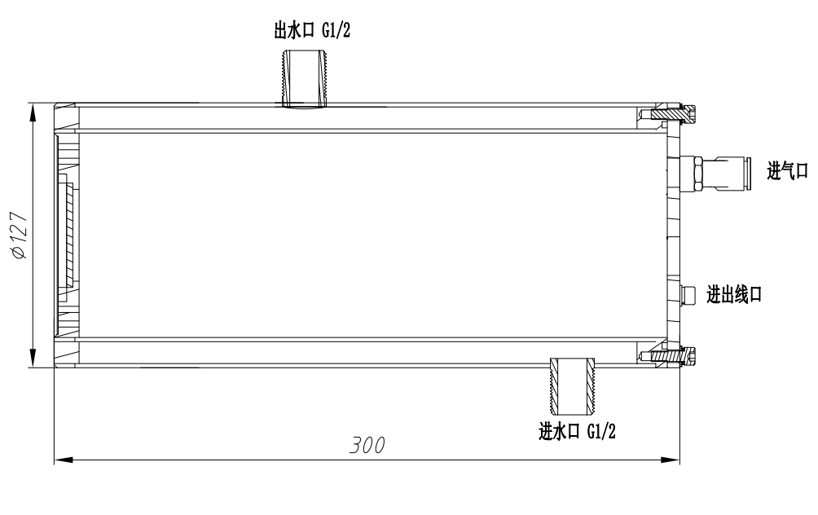

PSFCDG300-NS Structural dimensional drawing

1. **Installing Accessories**

* Air filter
* 2 5 meter stainless steel air pipes and 2 5 meter stainless steel water pipes

One 10m high temperature cable

* adjustable head support
* The assembly and pre-commissioning before installation have been completed before delivery

1. **System Software**

The system client software interface is shown in the following figure.



Figure 3 System software interface

The basic functions of the software are as follows:

* real-time video display: Real-time display of full radiation heat map and high-definition visible light video, you can view the temperature at any position in the infrared heat map, record, take photos, and analyze abnormal conditions.
* Temperature tracking: Automatically analyze the temperature upward trend of the entire infrared heat map or a specific area to find hidden areas in advance.
* Data capture: thermal imaging data can be periodically collected for further analysis.
* High temperature trigger shooting and alarm: When the temperature is abnormal,it can be found in time, then trigger the alarm, the software background will take infrared pictures and visible pictures during the incident.
* Fault self-diagnosis: When the terminal equipment is downtime, the system automatically alarms.
* User-defined alarm threshold and level: The system can define multiple different alarm thresholds and levels to assist the staff to assess the urgency and development of hidden dangers.

1. **Installation diagram**

