Handheld Thermal Monocular Camera

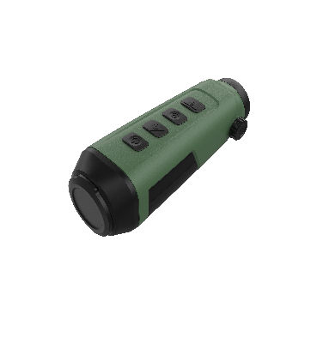

The handheld thermal monocular camera is a handheld device with functions of observation,highest temperature target tracking,distance measurement,WiFi hotspot and so on.The high-sensitivity built-in thermal detector provides you with clear view even in total darkness.The device is mainly applied to outdoor scenarios such as patrolling,law enforcement,searching and rescuing,drug enforcement,anti-smuggling,criminal seizing,hiking,travel and hunting etc...

Device Design：
- 330g lightweight body，controlled with one hand，held with comfort，carried with no burden,exploring the unknown wonders heartily；
- High performance built-in 12um thermal detector；
- Built-in battery，supporting external charging；
- Supporting tripod fixation；
- Supporting external display；
- 4 lens to choose：9.7mm、15mm、19、25mm；
- When the ambient temperature reaches 25 ℃ and Wi Fi and CVBS functions are turned off, it can operate continuously for 8 hours; When Wi Fi and CVBS functions are turned on, it can run continuously for 6 hours。

System function：
- Supporting Wi-Fi hotspot and TYPE-C interface；
- 8x digital zoom - better focus and better overall object recognition at long distances；
- 4 pseudo color：Black Hot, White Hot, Red Hot, Fusion；
- Support the functions of capture, video recording and reticle;
- The central area is magnified twice - to see the target details without losing the scene;

Parameter  Module | HS12E10 | HS12E15 | HS13E15 | HS13E19 | HS13E25
Sensor Type | Vanadium Oxide Uncooled Detector
Maximum Image Size | 256 × 192 |  | 384 × 288
Pixel Interval | 12 μm | 12 μm | 12 μm | 12 μm | 12 μm
Response Band | 8～14 μm
NETD (Noise Equivalent Temperature Difference) | ＜35 mK(@25°C,F#=1.0)
MRTD（Minimum resolvable temperature difference） | 500 mK
Thermal Imaging Lens Focal Length | 9.7 mm | 15 mm |  | 19 mm | 25 mm
Detection Range | 458m | 708 m |  | 897 m | 1180 m
Field of View | 18.00° × 13.55° | 11.69° × 8.78° | 17.5° × 13.1° | 13.8 ° × 10.4 ° | 10.5 ° × 7.9 °
Max Aperture Value | F1.0
Frame Rate | 25 fps |  | 50 fps
Display Resolution | 720 × 540 |  | 1280 × 960
Display | LCOS
Image Mode | Black Hot, White Hot, Red Hot, Fusion
Brightness Adjustment | 1~5 gears adjustable
Electronic Amplification | 1×，2×，4×，8×
Magnification | 1~8 | 1.42~11.36 | 1.47~11.76 | 1.86～14.88 | 2.45~19.6
Contrast Adjustment | 1~5 gears adjustable
Diopter Adjustment | Support
Wi-Fi | Support
Interface | TYPE-C
Capture Snapshot | Support
Video-recording | Support
Reticle | Support
Prevention of Burns | Support
Power Supply Mode | Built-in battery，supporting external charging
Storage | Built-in EMMC v5.1 interface high-speed storage (maximum 8 GB)
Battery life | When the ambient temperature reaches 25 ℃ and Wi Fi and CVBS functions are turned off, it can operate continuously for 8 hours; When Wi Fi and CVBS functions are turned on, it can run continuously for 6 hours
Operating Temperature | - 20~55 ℃
Ingress protection | IP67
Weight | ＜330 g
Size | ≤57 mm × 57.7 mm × 158.9 mm |  |  | ≤57mm×57.7mm×171mm

Packing List

Handheld Thermal Monocular Camera x1
Carrying bag x1
Instruction for use x1
lens cleaning cloth x1
Type C x1

