Thermal Weapon Sight with Clip On

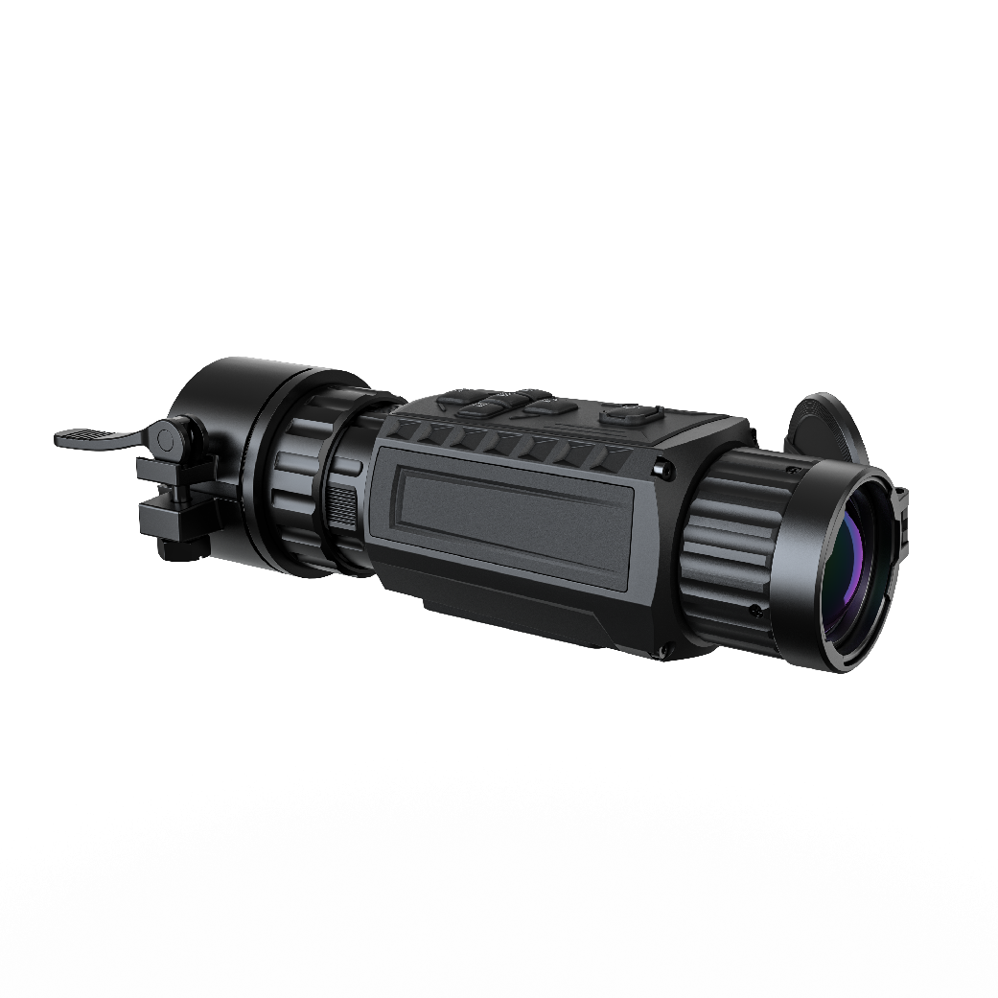

Thermal weapon sight with clip on, equipped with 640x512 infrared detector and 1024 × 768 OLED display ,can clearly see the target in harsh environments such as total darkness, smoke, dust, rain, snow, woods, and camouflage. It supports three modes of use: handheld, CLIP ON, and weapon-mounted use, and can be used in night patrols, outdoor hunting and other usage scenarios.

Thermal imaging functions：
- Adopt advanced passive infrared thermal imaging technology
- Resolution 640 × 512, high sensitivity detector
- Support 3D noise reduction function
- Support image detail enhancement function
- The focal length of the thermal imaging lens 50mm

Display features：
- Adopt 0.39-inch OLED display
- Resolution: 1024×768 for handheld and weapon-mounted use, 768×576 for CLIPON
- Eye relief: 10 mm for CLIP ON, 45 mm for handheld and weapon-mounted use

Power system
- Two CR123A/RCR123A type replaceable batteries for power supply
- can be used with USB external power supply
- run continuously for more than 4 hours

System function
- Support Wi-Fi hotspot
- Support digital amplification
- Support pseudo color mode switching
- Support ranging
- Support reticle

Parameter  Module | HM12E19-CO | HM12E25-CO | HM13E35-CO | HM16E50-CO
Sensor Type | Vanadium Oxide Uncooled Detector
Maximum Image Size | 256×192 | 256×192 | 384 × 288 | 640 × 512
Frame Rate | 25Hz | 25Hz | 50 Hz | 50 Hz
Pixel Interval | 12 μm
Response Band | 8 μm to 14 μm
NETD (Noise Equivalent Temperature Difference) | less than 35 mK (25 °C, F#=1.0)
Thermal Imaging Lens Focal Length | 19mm | 25mm | 35 mm | 50 mm
Detection Range | 950m | 1200m | 1800m | 2600m
Spatial Resolution | 0.63 mrad | 0.48mrad | 0.343 mrad | 0.24 mrad
Field of View | 9.24° × 7.08° | 7.03° × 5.39° | 7.5° × 5.7° | 8.78 ° × 7.03 °
Minimum Imaging Distance | 1m | 1.5m | 3.5m | 5m
Aperture Value | F1.0
Magnification | 2.5x | 3.25x | 3.0x | 2.6x
Eyepiece | 1024x768, 0.39 inch, OLED
Image Mode | Black hot, white hot, red hot, fusion
Exit Pupil | 6 mm
Exit Relief | 45mm
Diopter Range | -5 D to 3 D
Video-recording | Built-in storage
Capture Snapshot | Support
Standby | Support
Uniformity Correction | Support
Storage | Built-in EMMC (64 GB)
Picture In Picture | Support
Bad Point Correction | Support
Hotspot | Support
Electronic Amplification | 1X, 2X, 4X, 8X
Hot spot tracking | Support
Reticle | Support
Ranging | Unsupported
Battery | Replaceable，support  CR123A, RCR123A
Battery life | 7 hous(25 °C, Hotspot off) | 7 hous(25 °C, Hotspot off) | 7 hous(25 °C, Hotspot off) | 6.5 hous(25 °C, Hotspot off)
Battery Capacity Display | Yes
Battery Anti-reverse Protection | Yes
Overvoltage Protection | Yes
Charging via Type-C | 5 VDC, 2 A  support exteranl battery
Operating Temperature | -20 °C to 55 °C (-4 °F to 131°F)
Ingress Protection | IP67
Shock Resistance | 750 g/1 ms
Size |  |  | 179x68x63mm | 192x76x69mm
Weight |  |  | 532 g （without eyepiece and battery） | 583 g （without eyepiece and battery）
Interface | Type-C

Size：
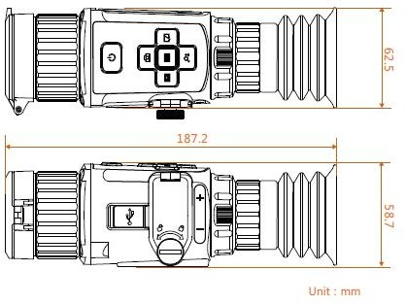

List：
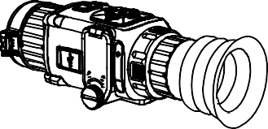


主机 x1 携行包 x1 电池 x2 说明书 x1


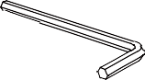
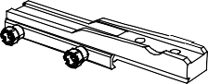
螺丝 x2 六角扳手 x1 皮轨 x1 拧紧辅助片 x1



擦镜布 x1 TYPE—C
连
接线 x1

主机： thermal weapon sight
携行包：carrying bag
电池：battery
说明书：instruction for use
螺丝：screw
六角扳手：hex wrench
皮轨：leather rail
拧紧辅助片：auxiliary piece for tightening
擦镜布：lens cleaning cloth
连接线：connection cable

